|  |
| --- |
| East London Science School |
| A-Level Computer Science Project |
| JarChat |

|  |
| --- |
| Adam Tazul  5-5-2022 |

# Contents

Contents 1

1: Analysis 2

1.1: Aims of JarChat 2

1.2: Target Audience 2

1.3: Research 2

1.3.1: Existing IRC Clients 2

1.3.2: Features of JarChat 4

1.3.3: Limitations of JarChat 4

1.4: Community input 4

1.5: Requirements 5

1.5.1: Software 5

1.5.2: Hardware 5

1.6: Success Criteria 5

2: Design 5

2.1: UI Design 6

2.1.1: Start-up Screen 6

3: Development & Testing: Part 1 6

3.1: Connection to IRC 6

3.2: The code used in the “library” 6

3.3: Sending messages, joining/leaving channels 7

4: Testing, Review and Evaluation: Part 1 8

4.1: Achieved Success Criteria 8

4.1.1: Proof of achieved Success Criteria 8

# 1: Analysis

## 1.1: Aims of JarChat

JarChat will aim to be a cross-platform IRC client which will support Windows, MacOS, Linux, and maybe more operating Systems not already listed. This will have the benefit of native cross-platform support as it is built-in to Java. Java’s JDK version 8 (Java version 1.8) will be used to compile all binaries as most computers still run JDK version 8, even though Oracle has moved their LTS (Long Term Support) version to JDK 11.

## 1.2: Target Audience

I expect everyone who uses a computer to be able to take advantage of JarChat. While most services have moved their IM services to other platforms (Microsoft Teams, Skype, Discord, TeamSpeak, etc.), various FOSS (Free and Open-Sourced Software) still use IRC as their support protocol, taking advantage of IRC’s decentralized nature.

JarChat can also expect to be popular with developers in any programming language, as there are still some programming help channels/servers hosted using IRC. The same will be true for new/existing users of most Linux distributions. Most of the time, if somebody has a question regarding Linux which can’t be answered by Google, they can ask in the appropriate channel on [Libera.chat](https://libera.chat/).

## 1.3: Research

### 1.3.1: Existing IRC Clients

#### 1.3.1.1: Windows

Existing Windows clients include mIRC and XChat.

##### 1.3.1.1.1: mIRC

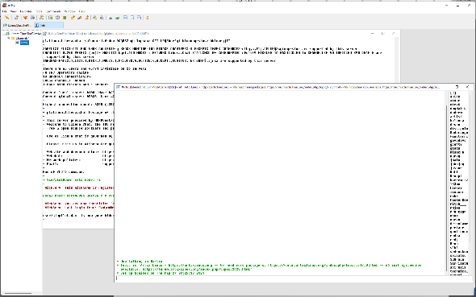mIRC is a paid and proprietary software which costs £17.94 (though it offers a 30-day free trial). It provides a slightly dated User Interface and was compiled in 32-bit form. This makes it compatible with 32-and-64-bit versions of Windows from Windows XP up to Windows 11. The UI makes use of a template too store different tabs as windows on a canvas. These windows cannot be moved or used in other parts of Windows. The settings menu leaves much to be desired and leaves few customization options. There is no option for IRC’s VOIP feature included with the software.

Figure 1: Default look of mIRC, running on Windows 11 build 22449.1000 (Dev Insider Preview).

I intend to take inspiration from mIRC's raw functionality as it just plain works (albeit only on Windows). I do plan, however, to expand this functionality to take advantage of all of the features that are included on IRC’s feature set.

##### 1.3.1.1.2: XChat

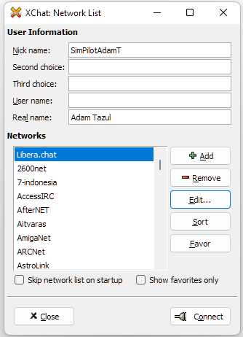XChat is another IRC client. Written in C, the Linux version is free and open-sourced under the GNU GPLv2 license. The client is precompiled for Windows and Fedora GNU/Linux, with forks available for Arch Linux (in the AUR), and with a precompiled *.deb file in the official Debian and Ubuntu repositories. The Windows version of the software is closed-sourced and proprietary, costing users US$19.99 (equivalent to £14.42 in September of 2021), though it offers a 30-day free trial. The Windows version officially supports all Windows versions from Windows 2000 up to Windows 10 (all in 32-bit).

Figure 2: The first screen of the Windows version of XChat, running on Windows 11 build 22449.1000 (Dev Insider Preview).

I tried to use XChat to connect to my favorite IRC server, but the Windows version failed to do so on Windows Vista, 7, 8, 8.1, 10, and 11. This lack of ease of use is an issue that I would like to resolve with JarChat.

#### 1.3.1.2: Linux

Existing Linux IRC clients include Konversation, WeeChat, and HexChat.

##### 1.3.1.2.1: Konversation

Konversation is a Linux IRC client which is tightly integrated with the KDE Plasma Desktop Environment. It is fully free & open-sourced under the GNU GPLv2 license. As a part of the KDE Applications suite. Konversation is precompiled for all major distributions of Linux & GNU/Linux, with source code hosted on the official KDE git repository ([https:/invent.kde.org/network/konversation](https://invent.kde.org/network/konversation)).

I use Konversation myself frequently as my main desktop setup is Artix Linux with KDE Plasma, and its tight integration means accurate and appropriate theming in line with the global QT5 theme, no matter what theme is used. It also uses Kcolorchooser to allow for the user to create a custom colour for Konversation’s theme, even if the user is not using a QT5-based theming engine.

Using Konversation, I found that it is a fully-featured client with support for every part of IRC, displayed in a user-friendly layout that is easy-to-use. I intent to take inspiration from this and remake these features in JarChat.

##### 1.3.1.2.2: WeeChat

WeeChat is a Terminal User Interface IRC client for Linux which can be used on any Linux Distribution without the need for any Desktop Environment or Window Manager. It is also FOSS under the GNU GPL v3 license.

While strictly TUI and Keyboard Interaction only (unless the setting is changed), WeeChat still provides a fully-featured experience with support for every part and situation possible in IRC, with every customization as needed by anyone who would use it. Since WeeChat is TUI, it is aimed at people who are willing to learn how to use it, which can take some time. For this very reason, there are a lot of people who have installed it, tried to use it, and then immediately uninstalled it as they found it extremely difficult to get started in (even with the existing documentation provided by the developers). This is completely understandable as WeeChat was designed with minimalism at the forefront of the developers’ minds.

##### 1.3.1.2.3: HexChat

HexChat is a cross-platform IRC client which supports all Linux Distributions via a Flatpak, its source code, .deb file, the official Arch Linux repositories, and more. It is also FOSS under the GNU GPL v2 license and features full support for Windows 7, 8, 8.1, 10, and 11. While it has Windows support, I am testing it on my install of Artix Linux (my setup will allow for testing with tiling window managers, floating window managers, Xorg, Wayland, Pulseaudio, and Pipewire).

#### 1.3.1.3: MacOS

Even though there are one or two IRC clients for MacOS, I do not have the means to test this. Creating virtual machines with MacOS installed on them have proved to create bugs at best, and hackintoshing (installing MacOS bare metal on computers not made by Apple) is also problematic, with stringent hardware requirements I do not meet. In any case, trying to do either will result in me breaking Apple’s EULA, which is legally binding.

### 1.3.2: Features of JarChat

JarChat is intended to include:

* Basic functionality as an IRC Client
* Cross-compatibility between various different operating systems without compromising on features
* Vast configurability through an easy-to-use UI
* GNU GPLv3 Open-Sourced license to allow for the community to better help shape the future of JarChat

### 1.3.3: Limitations of JarChat

The main limitation of JarChat is the fact that it will be written in Java, which means that JarChat will require and expect the user to have a JVM compatible with Java version 1.8.0 already installed on their system. While Java is generally installed on millions of computer systems globally, it cannot be guaranteed that everyone will be able to use JarChat for lack of the ability to install the software.

## 1.4: Community input

I am already taking input from the community about the project. Since all source code and development will remain public under the GNU GPLv3 license, it is relatively easy to get community input at every stage in the development cycle. To start things off, I posted an anonymous survey in the *#libera* chat in the most popular IRC server, [libera.chat](https://libera.chat/).

The questions in this survey include:

1. Roughly how many hours per week do you spend actively logged onto an IRC server?
2. Which servers do you frequent?
3. Which channels do you frequent in those servers?
4. What do you mainly do when logged into IRC?
5. What do you look for in an IRC client?
6. Which IRC client do you use currently?

The most popular answers are as follows:

1. Between 30 and 40 hours
2. Freenode (before the change of ownership), Libera.chat
3. Various Linux Distribution/software development support channels
4. Ask for/provide support from/to other users of the channel
5. Usability, theming, FOSS
6. A mix of Konversation, HexChat, and WeeChat

## 1.5: Requirements

### 1.5.1: Software

* Windows:
  + Vista SP2/Server 2008 R2 SP1 (or newer)
  + At least Internet Explorer 9, or Firefox (a dependency of Java)
* Linux:
  + Any distribution which has Java JRE version 8 in its repositories
  + Firefox (a dependency of Java)
* MacOS
  + MacOS X 10.8.3 or newer (not compatible with Apple M1)
  + Any 64-bit web browser (a dependency of Java)
* Java version 1.8 (OpenJDK JRE version 8 in most Linux repositories)

### 1.5.2: Hardware

* Windows & Linux:
  + Pentium 2 266MHz CPU or better
  + 128MB RAM or better
  + 124MB free secondary storage or better
* MacOS
  + An Intel CPU
  + 124MB free secondary storage or better

## 1.6: Success Criteria

In order to be successful, JarChat will need to:

* Function as a fully working IRC client
* Be usable for everyone who would need to use it
* Be able to use SSL encryption for servers which use it
* Run on any OS that Java version 1.8.0 can be installed on

In order to check that each criterion is met, JarChat will need to

* Be tested in every aspect that is needed of any IRC client
* Be distributed to various users with various skill levels in computer usage
* Be tested on every OS JarChat is likely to be run on
* Be tested in connections with servers that use SSL encryption

# 2: Design

Most design will be happening after the core code of the program is written, as UI design takes time.

## 2.1: UI Design

### 2.1.1: Start-up Screen

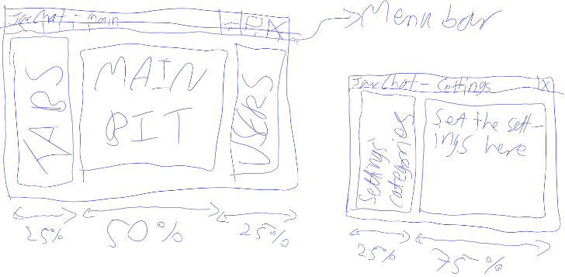On startup, I intend for JarChat to show the main window where server output will go, with a message in there if the user has not added any IRC servers. Alongside the main text area, there will be two other areas holding lists of connected servers/channels as well as active users in each channel.

Figure 3: First (rough) sketch of how the UI may to look like.

# 3: Development & Testing: Part 1

## 3.1: Connection to IRC

The actual connection to IRC is going to be handled by some code I found on a [GitHub Gist](https://gist.github.com/kaecy/286f8ad334aec3fcb588516feb72777) by [Kaecy](https://github.com/kaecy/), which seems to handle the connection decently and more stable than others I have found. I have made some edits to the code provided by Kaecy, ensuring it is well-commented, has static methods in line with my main class (called JarChat), has support for secure TLS connections, and has unnecessary parts removed. The code in the provided gist was originally created to be used in a bot, so did not need many of these features I deem required by JarChat.

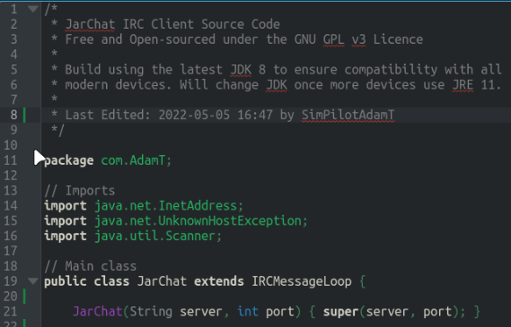The IRCMessageLoop class provided by Kaecy is an abstract superclass which JarChat needs to slightly extend on in order to be able to set up any kind of connection. To test the connection, I started to write the program in CLI form, in order to quickly set the server/user information and establish the connection. [Lines 38 and 39](https://github.com/SimPilotAdamT/JarChat/blob/d068d05590563a42e8bf200257415db126d1a913/Client/src/com/AdamT/JarChat.java#L38) of the source code (figure 10) as of the state of the code on 2022-05-02 at 23:17 currently create an instance of an object using the JarChat class, and then starts the connection. Using methods already declared in IRCMessageLoop, I was able to test and validate that the connection to the server was successul in this method.

Figure : The beginning of the main class file, showing the constructor of the JarChat class, as well as the necessary libraries being imported.

## 3.2: The code used in the “library”

The “library” used, as made by Kaecy, has several parts which have been edited by myself. For example, the extra code between [lines 27 and 35](https://github.com/SimPilotAdamT/JarChat/blob/d25516f23002be3660c77845ece4b00b755f32f5/Client/src/com/AdamT/IRCMessageLoop.java#L27) of IRCMessageLoop.java (figure 5) includes a custom implementation of the javax.net.ssl.SSLSocket and javax.net.ssl.SSLSocketFactory classes, in order to allow for most servers’ main connection method. Lines 45 through 57 (Figure 6) were made compact to reduce the overall size of the source code file.

Figure 5: The code which handles the actual Socket which connects to the IRC Server, with my own edits applied.

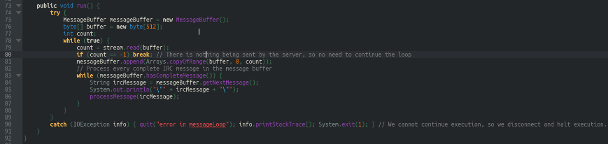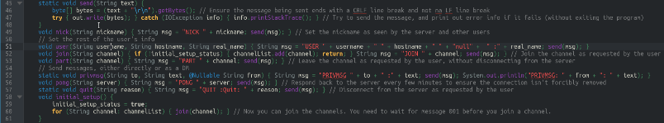The [processMessage() method](https://github.com/SimPilotAdamT/JarChat/blob/d25516f23002be3660c77845ece4b00b755f32f5/Client/src/com/AdamT/IRCMessageLoop.java#L63) in the IRCMessgeLoop class take in all messages being sent in through the socket and calls the appropriate method from figure 6 in order to process the input. The IRCMessageLoop class implements the Thread class and rewrites the [run() method](https://github.com/SimPilotAdamT/JarChat/blob/d25516f23002be3660c77845ece4b00b755f32f5/Client/src/com/AdamT/IRCMessageLoop.java#L73) (figure 7) in order to allow for it to read all outputs from the IRC server, and then calls the processMessage() method for each message.

Figure 6: The refactored code of the IRCMessageLoop Class.

Figure 7: The rewritten run() method.

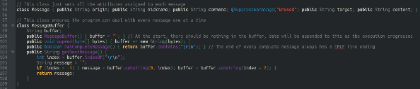The [Message and MessageBuffer classes](https://github.com/SimPilotAdamT/JarChat/blob/d25516f23002be3660c77845ece4b00b755f32f5/Client/src/com/AdamT/IRCMessageLoop.java#L94) (figure 8) are used so that there is a buffer to store messages in and to ensure that each message can be stored in its own object, setting each attribute. No constructor method is needed in the Message class because Java automatically handles this on creation of each object of type Message.

Figure 8: The Message and MessageBuffer classes.

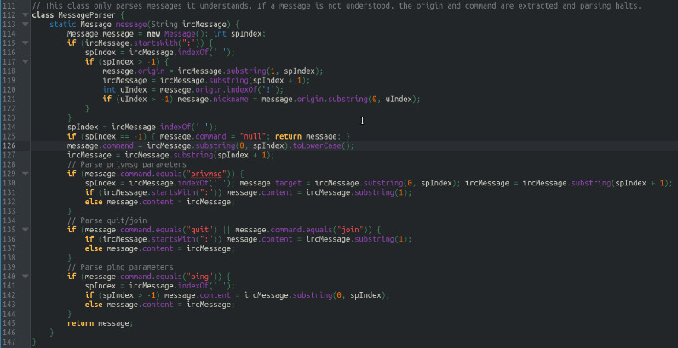The [MessageParser class](https://github.com/SimPilotAdamT/JarChat/blob/d25516f23002be3660c77845ece4b00b755f32f5/Client/src/com/AdamT/IRCMessageLoop.java#L111) (figure 9, called by IRCMessageLoop.processMessage()) parses each message received from the server into a way better readable by IRCMessageLoop.processMessage(). It also slightly beautifies each message for when it gets put into STDOUT.

## 3.3: Sending messages, joining/leaving channels

Figure 9: The MessageParser class.

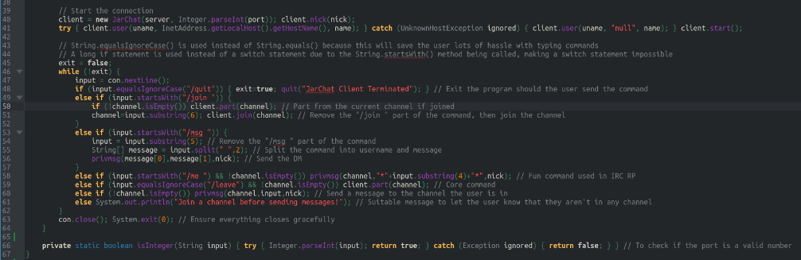[Lines 41 thru 60](https://github.com/SimPilotAdamT/JarChat/blob/4d0c75a027d4c7a782384d123060fab0f2f4f6ae/Client/src/com/AdamT/JarChat.java#L41) of my code (figure 10) as of 2022-05-02 at 23:23 show a while loop which keeps going unless the program is exited (either by [issuing a /quit command to STDIN](https://github.com/SimPilotAdamT/JarChat/blob/4d0c75a027d4c7a782384d123060fab0f2f4f6ae/Client/src/com/AdamT/JarChat.java#L46), or by [running into some kind of connection error](https://github.com/SimPilotAdamT/JarChat/blob/4d0c75a027d4c7a782384d123060fab0f2f4f6ae/Client/src/com/AdamT/IRCMessageLoop.java#L87)). For every thing sent to STDIN, the long if statement (used instead of a switch statement due to a [quirk in the way switch statements work](https://github.com/SimPilotAdamT/JarChat/blob/4d0c75a027d4c7a782384d123060fab0f2f4f6ae/Client/src/com/AdamT/JarChat.java#L41)) checks for valid messages or commands, with an appropriate error message for anything invalid. So far everything can only take place in a single IRC text channel. The user is able to send direct messages to several users at a time, but can only be connected to a single channel at any given time. I hope to be able to make use of the Thread class within a javax.swing GUI in order to allow for the user to send/receive messages to/from multiple channels at once.

Figure 10: The part of the JarChat class which handles the connection and the user's inputs to STDIN

# 4: Testing, Review and Evaluation: Part 1

## 4.1: Achieved Success Criteria

So far, as of 2022-05-05 at 22:30, JarChat has achieved the following:

* Function as at least a semi-workable IRC Client
* Ability to use SSL encrypted connections
* Ability to be run on any given OS that has a JVM
* Ability to chat with multiple users directly at the same time

The most important parts of this project that are so far missing are the following:

* OP/Administrative commands
* javax.swing GUI
* Ability to join multiple channels
* Ability to join multiple servers

### 4.1.1: Proof of achieved Success Criteria

I have been able to connect to Libera.Chat’s IRC server using JarChat in CLI (figures 11-12). The test shown here uses the TLS encrypted connection method and shows its success.

Figure 11: Collecting server/user info and connecting to the server.

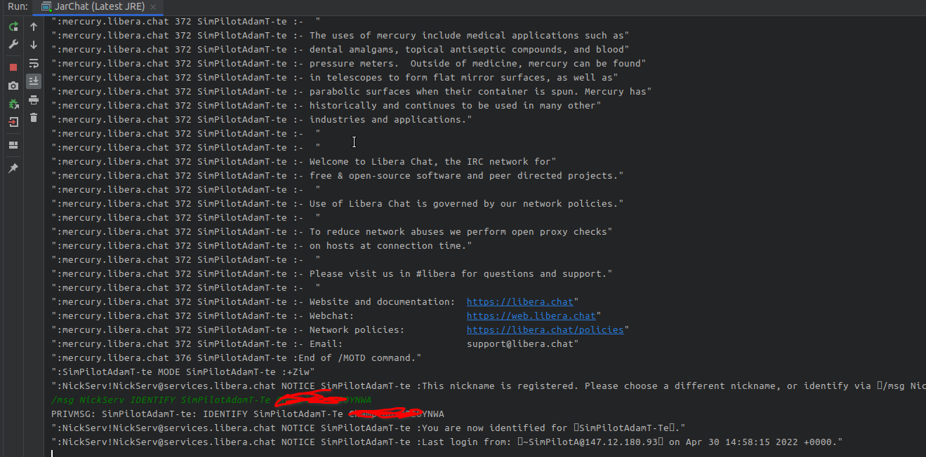Figure 12 shows the rest of the successful connection, with the login as managed by NickServ (a popular “login” bot used in IRC servers), with the password censored out.

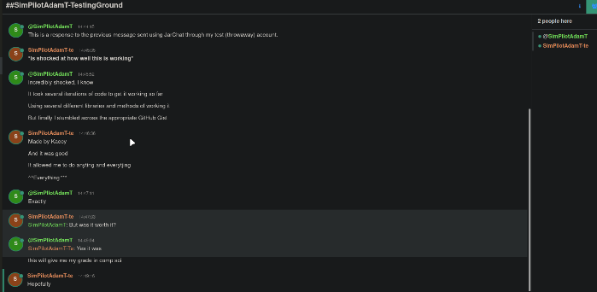Figures 13 & 14 show several messages being sent back and forth between my account on Jar Chat and my main account on Libera.Chat’s WebChat feature.

Figures 13 & 14: Messages being sent back and forth in the test channel I created on Libera.Chat

Figure 12: Successful connection, with login.

